Gilbert Lake, Crow Wing County, Loon Liaison – Paul Jacobsen
Jech, Jayden (He/Him/His) (DNR)
MN DNR

2022: Template created by Spencer Rettler and Rob Rabasco (MN DNR)
2022: Template approved by United States Fish and Wildlife Service (USFWS)
October 2023: Jayden Jech (MN DNR) integrated Gilbert Lake information
October 2023: Jayden Jech sent plan to Paul Jacobsen (GLA) for review
October 2023: Paul Jacobsen sent additions and Jayden Jech integrated additions into the plan.
October 2023: Jayden Jech resent final plan to Paul Jacobsen.

Gilbert Lake Association
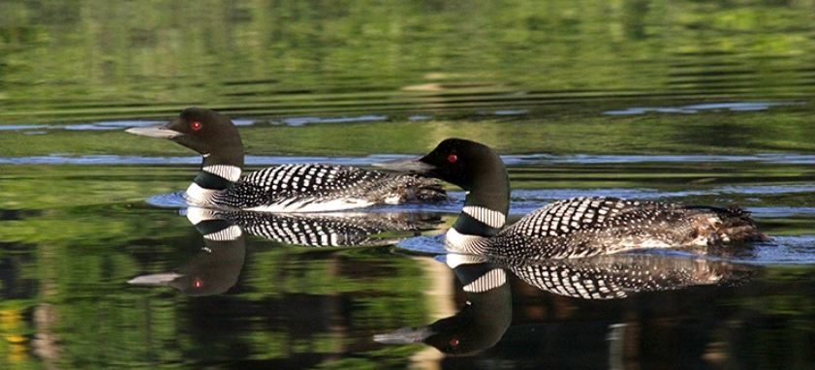

Common Loon (Gavia immer)
Friendly Lake Management Plan

October 2023

The intent with this template is to ensure key information is included in each lake plan but also to allow for flexibility and customization to each lake and situation.

Objectives
Describe the objectives of the plan (e.g., conserve loons), how the plan will be implemented, coordination with partners (e.g., MDNR, Watershed District, other lake associations, etc.).
The Gilbert Lake Association (GLA) will work with the Minnesota Department of Natural Resources (MN DNR), and associated partners of the Restoration of Common Loons in Minnesota Project (RCLMP), to conserve loon populations on Gilbert Lake in Crow Wing County Minnesota. By way of this plan, Gilbert Lake is enrolled in the MN DNR RCLMP Loon Friendly Lake Registry (LFLR). Enrollment in the LFLR is how the GLA will conserve loons on Gilbert Lake. Gilbert Lake Association has urged members and lake goers to avoid loon nesting areas, and to be aware of loons when boating.

Loon Use
Describe what is known about loons use on the lake, including a description of the number, history, locations of territories, and descriptions of the management activities within territories. Describe the habitat conditions/characteristics, foraging resources, nesting chronology, chick productivity, and existing monitoring/conservation efforts for loons on the lake. Include a map that denotes the territories. Loon use information may be used to identify future management action, e.g. protection of important shoreline nesting habitat.
Gilbert Lake had been a part of the Loon Watcher Survey (LWS) from 1988-2009. The number of loons observed on the lake was typically 2, however, it ranged from 0-4. During this time, loons have been recorded nesting on the lake nearly every summer during survey years. On average, there was 1 nesting pair identified, yet there were as few as 0. The number of chicks observed has typically been 0-1, but it has ranged from 0 to 2 chicks. No Artificial Nesting Platforms (ANP) have been deployed during the survey years.
Gilbert Lake Association Report: Since the end of the LWS in 2009, residents on the lake have observed 3-4 pairs of loons on the lake, with most of them believed to be nesting pairs. The territories of the loon pairs are usually one in the east bay (known as Gilbert 1), one or two pairs in the large bay (one on the east side, one on the west), and one pair in the far west bay (Gilbert 3) or in the narrow channel between Gilbert 3 and the main lake. For the summers of 2022 and 2023, a resident on Gilbert 1 has placed an artificial nesting platform in Gilbert 1. In 2022, two chicks hatched on this platform, but neither survived. In 2023, one chick hatched and survived.
MN DNR has classified Minnesota’s lakes into 43 different types based on physical, chemical, and other characteristics. Gilbert Lake is a class 25 lake. Class 25 lakes are generally large lakes with irregularly shaped shoreline. They support centrarchid fishes and can support walleye. Yet, Gilbert Lake has no known naturally spawning walleye. The littoral area is 226 out of a total of 357 acres (~63% of lake area). Furthermore, Gilbert Lake is classified as a General Development Lake, with approximately 188 individually owned parcels along the lake shore. Gilbert Lake is considered a Lake of Biological Significance (LBS) by the MN DNR and its fish community is classified as moderate.

Loon Threats
Describe current threats to loons on the lake, including disturbance from human recreational activities, inadequate or limited nesting/foraging habitat, predators, poor water quality, fluctuating water levels, shoreline development, fishing line/lure entanglement, and contaminants (e.g., mercury, lead, organic compounds). Threats to loons may vary per lake, e.g. higher levels of human disturbance on more densely developed lakes.
As General Development Lakes, the loons on Gilbert Lake are exposed to high levels of disturbance by boat and recreational watercraft traffic. A significant number of Gilbert Lake residents operate wake and surf boats, which are designed to create larger wakes than traditional ski boats. There has been controversy among lake residents about the effects of the wakes on habitat and the lakeshore, especially during high water years, like 2020 and 2021. Most of the heavy wake traffic is in Gilbert 1 and the main bay, as there is little recreational speedboating in Gilbert 3.
Additionally, with the vast majority of shoreline in private ownership on Gilbert Lake, natural loon nesting habitat may be a limiting factor for loon populations. MN DNR conducted an analysis on Gilbert Lake as part of the Sensitive Lakeshore Assessment Project (SLAP). The SLAP was initiated to identify lakeshore areas of unique or critical habitat, or high biological diversity. As a result, there were multiple shoreline areas, totaling 457 acres, identified on Gilbert Lake as ‘Highly Sensitive’. Most of the main part of Gilbert Lake is developed, with impacts on nearshore habitat due to aquatic weed removal and boat traffic. Gilbert 1 has better habitat, but it is narrow and thus susceptible to boat activity. Gilbert 3 and the channel leading to it have most of the natural shoreline habitat in place, as most of it is publicly owned. The GLA has tried in the past to have the channel between Gilbert 1 and the main bay (near the public landing) subject to a no-wake zone, but Crow Wing County has not been supportive.
With a public water access, this lake offers excellent multi-species fishing opportunities, thus, potentially exposing loons to lead fishing tackle. Gilbert Lake is typically subject to high fishing pressure for crappies and panfish in the spring during the crappie spawn. The channel between Gilbert 3 and the main lake becomes subject to heavy boat traffic, as the best crappie fishing locations are in the channel and Gilbert 3. Loons have nested in the channel, and heavy boat traffic often came close to the nests. In recent years, nesting activity has not occurred in the channel, and appears to have moved out to the main part of Gilbert 3. Fishing pressure tapers off in the summer, with most anglers seeking bass and panfish. However, recreational traffic uses frequently uses the channel between the main lake and Gilbert 1 all year. Most residents go at a no-wake speed, but boaters are observed speeding through this channel at times.
Aquatic invasive species (AIS) have been identified in Gilbert Lake, specifically zebra mussels. Boaters must follow all MN DNR AIS rules, regulations, and procedures to prevent the spread of zebra mussels and other AIS.

Management Recommendations to Benefit Loons
Describe management recommendations and strategies to protect loons and increase productivity. Identify short, mid, and long terms actions. Management actions might include nest and nursery protections via signs, buoys, and area closure, development of a monitoring program, annual deployment of artificial nesting platforms, an advocacy program to promote the use of non-lead fishing tackle, placing shorelines in conservation easements, and landowner outreach.

Management actions on Gilbert Lake to protect loons and increase loon productivity are based on enrollment in the LFLR. Participation in the LFLR includes the following loon conservation steps:
- Establishment of a Loon Liaison (LL) as the GLA representative that partners with MN DNR to assist in guiding loon conservation on Gilbert Lake. Gilbert Lake resident Paul Jacobsen, a GLA member and former GLA president from 2000-2011 and a University of Minnesota Extension Service Master Naturalist, has volunteered to be the initial LL.
- The LL, or selected lake association member(s), will partner with MN DNR to train association members as volunteers to assist with loon monitoring through the MN DNR Loon Watcher Survey program.
- The LL, or selected lake association member(s), will integrate loon conservation information into GLA newsletters, websites, and agenda items in meetings. The GLA has a robust website (https://www.gilbertlake.org/) and will integrate loon conservation information into that website.
- The LL, or selected lake association member(s), will provide loon conservation information at key lake access points (pending MN DNR Parks and Trails Division and/or county permission), and invite Minnesota Pollution Control Agency Get the Lead Out Program staff to speak at GLA meetings.
- If deemed appropriate by MN DNR and USFWS/USGS RCMLP staff, the LL, or selected lake association member(s), will assist in the optimization of the construction and annual deployment of artificial nesting platforms.
- The LL, or selected lake association member(s), will employ the following strategies to reduce the use of lead-based tackle on Gilbert Lake: encouraging members to dispose of lead tackle at Household Hazardous Waste sites, and hosting a lead tackle drop-off event with lake association members. There is a potential opportunity to have MPCA and/or MN DNR speak during spring 2024

Background

Best Practices for Loon Nesting and Chick Rearing

A number of factors may explain why loons are not nesting on the lake, including lack of nesting habitat, poor food base, or high levels of human disturbance. If territorial loons nest on the lake but have a history of nest failures, you should first work to enhance natural nesting sites. This might be through regulations such as a slow-no-wake zone near the nest coupled with signage (check with your local Law Enforcement Unit or Sheriff’s Office to obtain permission), contacts with the landowners about naturalizing shorelines, or educational programs for lake residents or users. The GLA has tried several times to have Crow Wing County enact a no-wake zone in the channel by the landing, but the Crow Wing County Sheriff’s office has not been supportive. If natural nest sites are not available and cannot be restored, and factors leading to nest failure are controlled, then artificial nesting platforms are a consideration.

The best way to enhance long-term health of loons across Minnesota is to protect natural nesting and foraging habitat. Maintaining shorelines in natural, undisturbed vegetation assures that loons have nesting habitat, as well as access to foraging areas near their nests. Habitat alteration surrounding nesting sites, may deter loons from using those sites in subsequent years. Lakescaping and shoreline restoration can provide more suitable nesting habitat for loons than traditional lawns and rock rip-rap During the early 2000s, the GLA promoted lakescaping and provided residents with written information promoting not disturbing the natural vegetation along the lakeshore. Slowly, more residents are integrating lakescaping into their shorelines, and fewer residents are mowing down to the water. However, with record high waters in 2020, many shorelines eroded, causing many residents to install rip-rap along the shore, which may impact nesting habitat. For more information, please consult the MDNR Lakescaping and Shoreland Restoration Program https://www.dnr.state.mn.us/lakescaping/maintaining-and-restoring-natural-shorelines.html.

Best Practices for Limiting Human Disturbance
The primary anthropogenic impacts on loon breeding habitats are noise and visual disturbance to adults (both of which may result in failed reproduction), and lakeshore development. Physical disturbance of adult loons after eggs have been laid may flush loons from their nest, and cause total nest failure. Loons vary in their tolerance to boat traffic, but may leave the nest if watercraft comes within 500 feet of the nest. This leaves the eggs without warmth or protection from predators. Loons may also permanently abandon a nest if disturbed too often. Additionally, boat wakes may ‘swamp’ nests or wash eggs off of nests. If loons that are approached start to call and/or stand-up straight out of the water, they are alarmed by the proximity of a boat/personal watercraft. Personal watercraft and motorboat operators can help significantly by staying away from shorelines, and keeping a safe distance from foraging loons.

Best Practices for Loon Foraging
Loons have several characteristics that make them a valuable “indicator” of the health of a lake. As diving birds that use sight to hunt prey, they thrive in clear lakes with healthy fish populations. Taking steps to monitor and maintain water clarity and quality may preserve foraging opportunities for loons. The GLA tests the lake in two locations five times every summer. Water quality has stayed constant over the past 30 years, with water clarity increasing after zebra mussels were established in the lake. Secchi dish readings of more than 30 feet have been observed during the first testing in May of each year. For more information consult the MPCA Citizen Water Monitoring Program www.pca.state.mn.us/water/citizen-water-monitoring. Informing the angling public about risks related to lead fishing sinkers and lures (i.e. jigs) and encouraging use of non-toxic materials can also mitigate negative effects on foraging loons https://www.pca.state.mn.us/living-green/lead-free-fishing-tackle-get-lead-out.

Learn More
There are effective strategies for reaching out to lakeshore landowners, including;
  - Promoting a Loon-Friendly Lake Registry Program for lake associations within the focus area for the Restoration of Common Loons in Minnesota Project.
  - Train lake association members as volunteers to assist with loon monitoring on lakes registered in the Loon-Friendly Lake Registry Program.
  - Integrate loon conservation information into lake association newsletters, websites, and as agenda items in meetings.
  - Provide loon conservation information at key lake access points.
  - Invite MN DNR staff to speak about the MN Loon Restoration Project, loon conservation, and citizen loon monitoring programs at lake association meetings. MN Loon Program Coordinator: MLRP.DNR@state.mn.us.
  - Invite MPCA to speak about the Get the Lead Out Program at lake association meetings: leadout@state.mn.us
  - Include Get the Lead Out information in lake association newsletters, websites, and as agenda items at meetings.

Education is the best way to encourage loon awareness and good boating behavior. Contact MN Loon Restoration Project staff MLRP.DNR@state.mn.us if you are interested in an educational brochure to share with lake residents and users titled “Be Loon Aware” that describes responsible watercraft use to help limit conflicts between boaters and loons.

Appendix A:
Loon Monitoring Protocol
Volunteer Loon Survey – Survey Tips
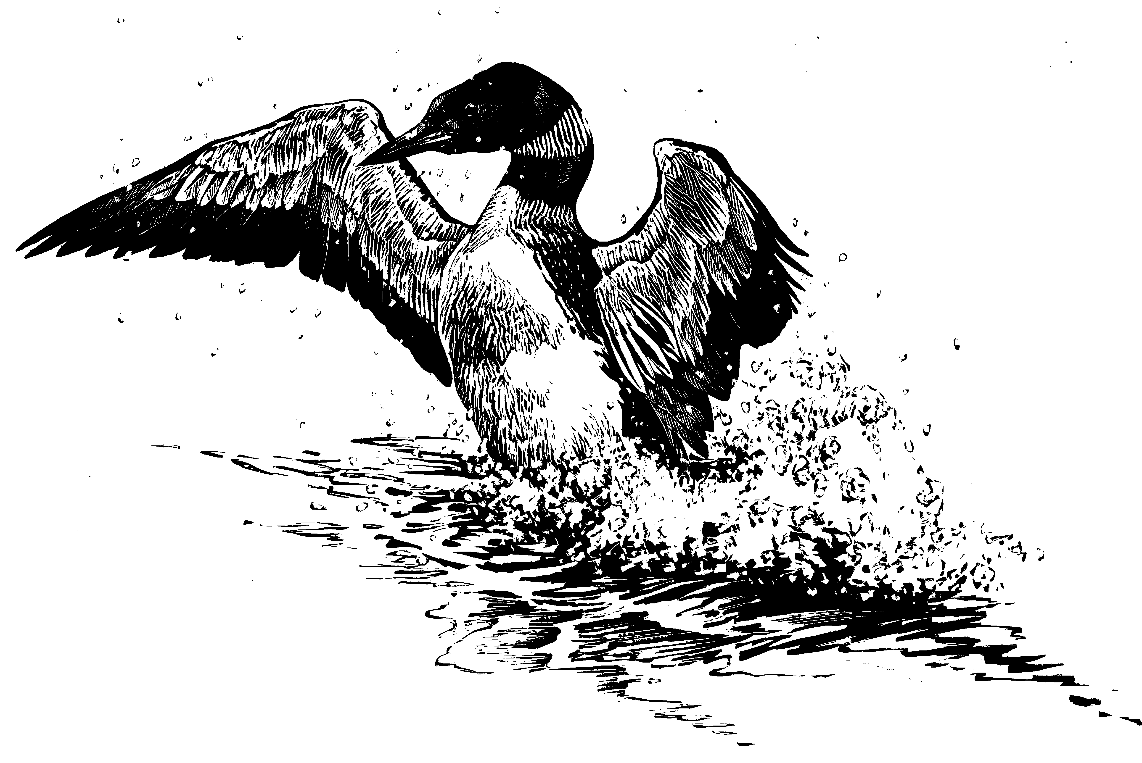
Minnesota Dept. of Natural Resources
Nongame Wildlife Program
www.dnr.state.mn.us/eco/nongame/projects/mlmp_state.html
Contact Volunteer Loon Watcher Survey Coordinator LoonWatcherSurvey.dnr@state.mn.us
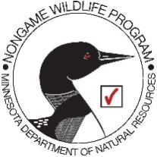

General survey tips

1) When to Survey:
    - Do not survey in heavy rain or whitecap conditions. Loons are very difficult to see in choppy water conditions (>7 mph wind speed, crest break, white caps). If the weather is bad, reschedule your survey for another day. Watch the forecast and plan your surveys accordingly.
    - Early morning and late evening generally provide the best survey conditions.
    - Try to avoid disturbing the loons – observe them from a distance.

2) What you will need:
    - Binoculars and/or spotting scope
    - Map of lake for navigation and marking nest locations
    - Be careful – wear life vests in boats and canoes
    - Bird identification guide book – you may note other bird species present on the lake that you may want to add to your comments section on the data sheet.
    - Ask for permission before crossing private land

Other important Information
- Loon Facts
    - Most breeding pairs of loons will have 0 - 2 young
    - Lakes smaller than 200 acres are unlikely to have more than 1 breeding pair of loons, which means that most small lakes will not have more than 1 or 2 juvenile loons.
    - Adult loons frequently fly to other lakes for feeding and social interactions. Thus while you survey your lake, any loon(s) associated with your lake may be off your lake, or an “extra” loon could be visiting.
    - Chicks up to 1 – 2 weeks of age have gray downy feathers. Juvenile loons are brown and gray from 2 – 4 weeks and then turn gray and white after about 4 weeks of age.
    - Female and male adult loons are indistinguishable by feather pattern and color. Males tend to be slightly larger. They share nest and chick-raising duties equally on average (it’s a myth that only “mom” tends to the nest and young).

- Monitoring Tips
        - Count all loons on the lake including those leaving or landing. Do not count loons that fly overhead but do not land.
        - Count only the loons you see but use calls to help you find other loons.
        - Be careful not to count cormorants as loons – from a distance they can look similar. Use binoculars to look for white on the breast of any bird that looks like a loon. Cormorants are entirely dark.
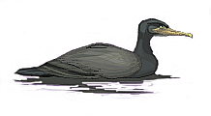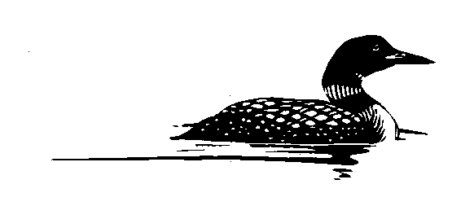
Double-Crested Cormorant Loon

  - Surveying from Shore:
    - Make sure you can see the entire lake.
    - View the lake from multiple vantage points, if necessary (Example 1).
    - If you cannot see the entire lake, view for a longer period of time in case there are loons “around the corner”.

Example 1:
Suggested route for surveying by shore

  - Surveying by Boat:
    - Round Lakes: stay about 200 feet from shore while moving around the lake.
    - Narrow, long Lakes: move back and forth (zig-zag) down the length of the lake.
    - Large lakes (>400 acres): Survey under calm, windless conditions with low boat traffic (which conditions will typically occur in early morning). Have 3 people in the boat (1 driver, 2 observers). Scan to the FRONT, SIDES and BEHIND the boat…if you see a loon, stop and survey for a minute. Note the location of the loon and any direction of its movement. Be careful not to double count loons as you move around the lake (keep track of the loons you observe).
      - Stop the boat every 400 yards to fully scan the lake with and without binoculars. With the motor off, you can hear loon calls from all parts of the lake.
      - Be conservative…if you think you may have already counted one or more loons, do not count them again.
7
10
4
3
2
START
11
8
6
5
1
9
12
STOP 17
14
13
16
15
Example 2:
Suggested route for observing by boat

Appendix B:
Strategies for Promoting the Use of Non-lead Fishing Tackle
Lead is a toxic metal that has adverse effects on the nervous and reproductive systems of animals, including loons. The Get the Lead Out Program, administered by The Minnesota Pollution Control Agency (MPCA), and supported by the MN DNR, and the U.S. Fish and Wildlife Service, serves to reduce the use of lead fishing tackle.
General Concerns:
- Even in small amounts lead is lethal to loons and other wildlife including eagles and trumpeter swans.
- Loons pick up lost lead tackle while gathering pebbles for their gizzards.
General Strategies
- Organize a lead tackle exchange:
  - Include information on a lead tackle exchange in the lake association newsletter.
  - Place lead tackle exchange information on the lake association social media pages.
  - Hold a lead tackle exchange event at the annual lake association annual meeting.
  - Find a household hazardous waste collection site through the MPCA: https://www.pca.state.mn.us/waste/find-your-household-hazardous-waste-collection-site
- Provide non-lead fishing tackle information to lake association members.
  - Include non-lead tackle information, including lists of products/manufacturers, in lake association newsletters.
  - Share the MPCA’s lead-free manufacturers website for options to buy lead-free tackle: Manufacturers of lead-free tackle
  - Include MPCA Get the Lead Out webpage and social media links on lake association social media pages.
  - Encourage members who want to dispose of lead tackle to contact their local Household Hazardous Waste site.
  - Contact MPCA’s Get the Lead Out program at leadout@state.mn.us to acquire lead-free tackle sample packs for distribution at lake association meetings.
  - Secure permission to post educational signage about fishing lead-free at high visibility shoreline areas.
  - Ask an association member to volunteer to be the leader and organizer of Get the Lead Out activities for your lake.
  - Include Get the Lead Out messages and articles in your newsletters and communications with association members.
- Invite MPCA Get the Lead Out staff to speak at lake association meetings: Email leadout@state.mn.us for more information.
- Talk to your favorite retailers and ask them to stock non-lead fishing tackle.

Appendix C
Best Management Practices for Artificial Nesting Platforms
Artificial nesting platforms have been used to increase loon nesting success in many states. While they have been effective at enhancing loon productivity and are very popular with lakeshore residents, artificial platforms do not ensure nesting success.
Important: Individuals or Lake Association volunteers are responsible for maintaining artificial nesting platform for its lifetime. This responsibility includes: placing platforms on the lake soon after ice-out, removing it in late summer, storing it on shore, and making necessary repairs at the end of the season. Platforms are a long-term responsibility. If the nesting platform is not properly maintained, it may cause the nest to fail, or not provide an appropriate substrate for successful loon nesting.
Artificial nesting platforms are not always the answer.
- Platforms may seem like an “easy out” from the true challenge of balancing human lake use and the habitat needs of loons and other species. Protection of nest and habitat from development, coordination of water level fluctuations to protect nests, and an understanding of specific lake habitat suitability are essential.
- There is no guarantee that loons will use a platform and, in fact, artificial nesting platforms can sometimes create problems for loons. For example, predators such as crows, gulls, or eagles may more easily locate nests on platforms. Avian guards can be added to nest platforms to reduce the risk of predation by birds. In addition, curious humans can impact loons by boating too close to a platform and frightening loons from the nest.
- The best way to enhance long-term health of loons across Minnesota is to protect natural nesting and foraging habitat.
Consider the following questions and steps as guidance for evaluating the appropriateness of an artificial nesting platform.
If loons have established a territory and are nesting on the lake, start here.
If you answer yes to Questions 1 – 3, then a platform is probably not the right option for the lake.
1. Do loons produce chicks on the lake?
2. Do loons successfully nest on a nearby lake most years?
3. Are there natural nesting locations on the lake that could be enhanced through means other than placing an artificial platform, e.g. protection of shoreline?
If loons are not nesting on the lake, start here.
You need more information to understand loons are not nesting on the lake. Check historically records, or record your own observations, to answer questions 4 – 7.
- Do you know that historically loons nested on the lake?
- Can you identify territorial loon behavior (exhibiting defensive postures such as the penguin dance, evidence of pairing (i.e. parallel swimming, courtship behavior) separate for behavior of non-breeding resident loons or just occasional visitors?
- Is the lake subject to water level fluctuations that may flood nests? This may be a reason to consider an ANP.
- Has unsuccessful nesting been observed? If so, try to document locations, numbers, and causes of nest failure. Please report to the MN Loon Restoration Project Coordinator at MLRP.DNR@state.mn.us.

More to consider
A number of factors may explain why loons are not nesting on the lake. These include: lack of nesting habitat, poor food base, high levels of human disturbance, or simply that the loons are successfully nesting on a nearby lake.
If territorial loons nest on the lake but have a history of nest failures, including being subject to nest predation, you should first work to enhance natural nesting sites. This might be through regulations such as a slow-no-wake zone near the nest, contacts with the landowners about naturalizing shorelines, or educational programs for lake residents or users that address human disturbance.
Until the summer of 2023, residents had not seen loon chicks on the lake for at least 5 years, though loons had been observed on nests during those years. The existing ANP in Gilbert 1 had a successful hatch of two chicks in 2022 (but both did not survive long-term), and of one successful chick hatch in 2023, which survived. The high level of fluctuating water on the lake (over 6 feet over a decade) may be swamping nests. Bald eagles frequent the lake, and an eagle successfully hatched and raised a juvenile eagle this spring on property abutting the lake. Further, raccoons and skunks have been known to frequent the shoreline for food. Finally, getting a no-wake zone in the channel by the public landing may help with loon nesting success in that area.
If natural nest sites are not available and cannot be restored, and factors leading to nest failure are controlled, then artificial nesting platforms are a consideration. The most appropriate locations for artificial platforms are lakes where natural nesting sites have been developed, water levels fluctuate severely (such as reservoirs), or where loons nest on mainland shores and have lost their eggs to shore predators, such as raccoons, etc. Artificial nest platforms should be placed within existing loon territories away from existing loon territory boundaries to reduce conflict between neighboring territorial loon pairs.
If you are considering an artificial platform, please do the following:
- Contact MN Loon Restoration Program Coordinator MLRP.DNR@state.mn.us for help in selecting an appropriate location. ANP construction and placement guidelines are being developed by MLRP staff.
- Check with your local Law Enforcement Unit or Sheriff’s Office to obtain permission or a permit for platform placement.
- Select a site such that platforms do not interfere with boating traffic.
- We encourage you to involve your lake association in any plans.
- Monitor the nesting success of loons on the lake as well as use at platforms. Consider joining MN DNR Loon Watcher Program.
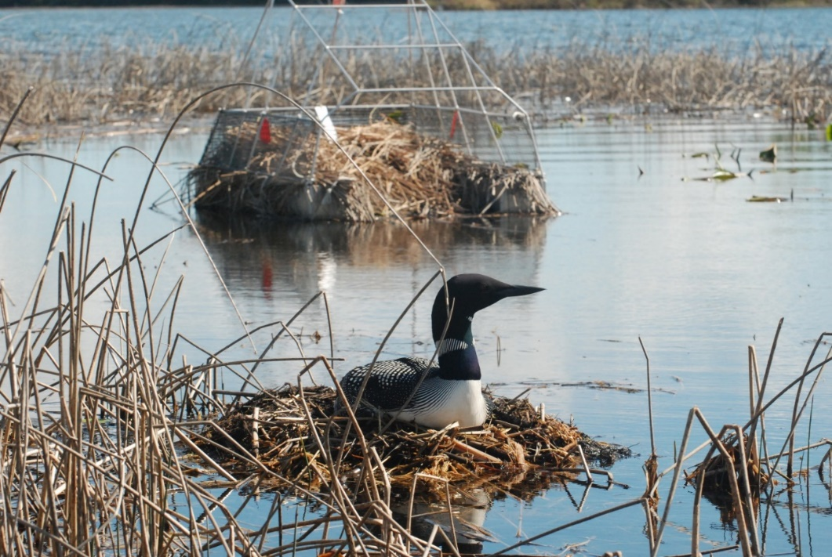
Loon nesting on natural substrate adjacent to an ANP.

